Assignment 7
Ch: 27:
57.58,59,60,61,68.
Q2 .A 5.00µF capacitor is charged to a potential difference of 800V and then discharged through a 25.0-kΩ resistor .How much energy is delivered to the resistor in the time it takes to
fully discharge the capacitor?

Q3.
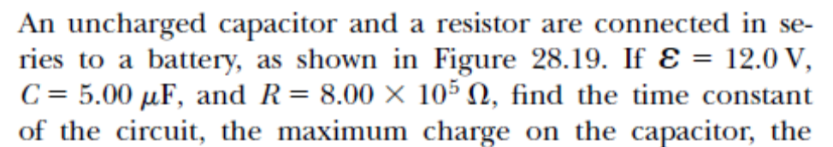
Find charge on the capacitor after 1sec, 2sec , RC, 2RC,3RC and 10RC. Do the same for potential across the capatitor and poetential energy stored in the capacitor.

Now that after charging process is over, we remove the battery, the capacitor starts discharging. Do the similar calculation for this case too.
Find, q(t), i(t), U_{E} (t) at those time.

